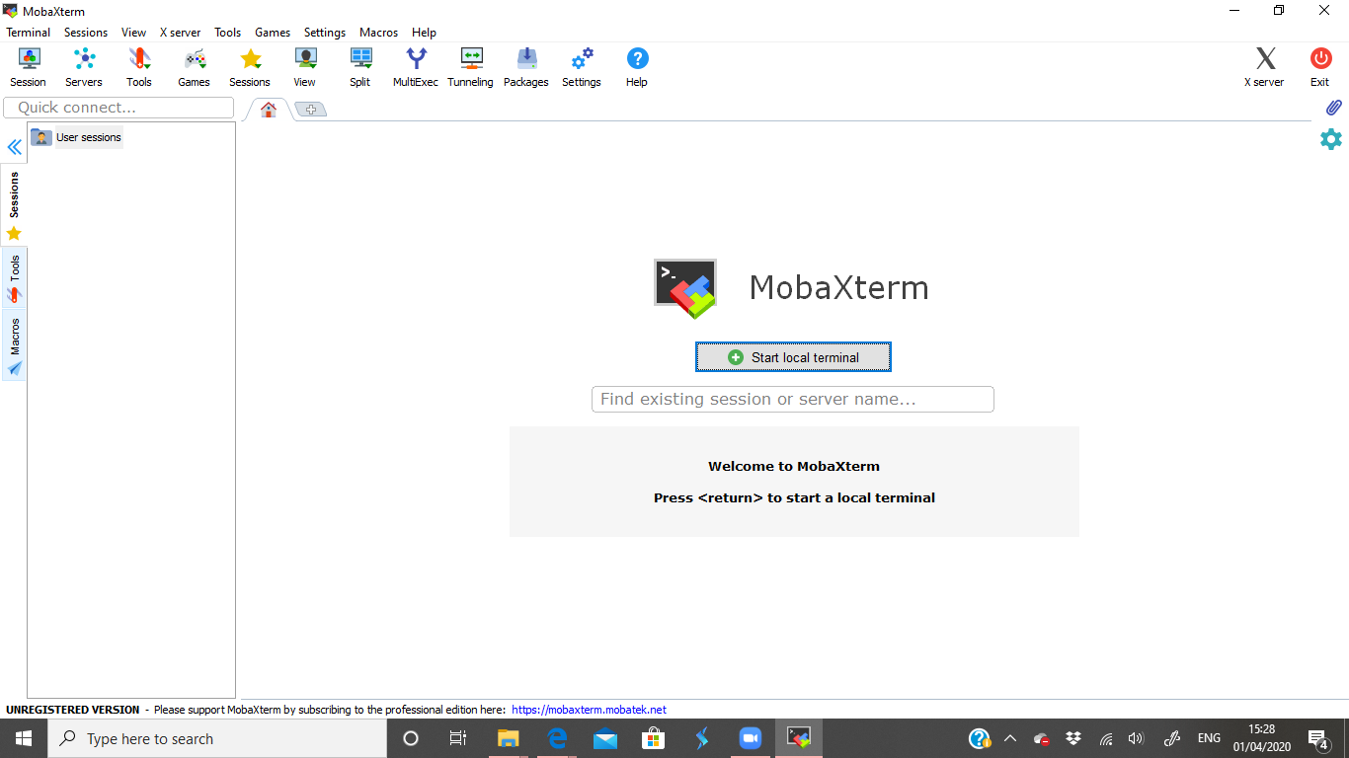

<https://mobaxterm.mobatek.net/download-home-edition.html>

Download home version

Connect to VPN

Session

SSH

Host

fac-login-1.hpc.dc.uq.edu.au

fac-login-0.hpc.dc.uq.edu.au

Specific username: uqrlyon4

AdvancedSSH settings

Terminal: Solarised dark

Bookmark

Session name = agro1